Google Cloud Storage
Defination :
- Cloud Storage is a managed service for storing unstructured data. Store any amount of data and retrieve it as often as you like.
- The Data stored into Bucket.
Types of Storage :
- Standard storage - Frequent access, Long time storage.
- Nearline Storage – Low cost, Infrequent data access, 30 days.
- Coldline Storage - Infrequent data access, 90 days.
- Archival Storage – Low cost, online backup, Disaster recovery, 365 days.
Use:
To use cloud storage, you’ll first create a bucket, a basic container that holds your data In cloud storage. You’ll then upload objects into that bucket – where you can download, share, and manage objects.
Python Lib - from google.cloud import storage

GCS Architecture :
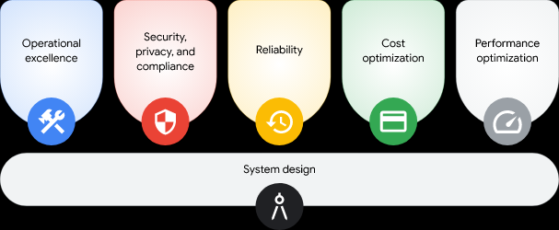
The google cloud architecture has 6 parts of pillars.
System Design :
Operational excellence:
- Efficiently deploy
- Operate
- Monitor
- Manage cloud workloads
Security, privacy, and compliance:
- Maximize the security and workload.
- Design for privacy and alignment.
Reliability:
- Design and operate resilient( quickly from difficult conditions.) , High available workload.
Cost optimization:
- Minimize the cost value of the business investment.
Performance optimization:
- Design and tune your cloud resources for optimal performance.

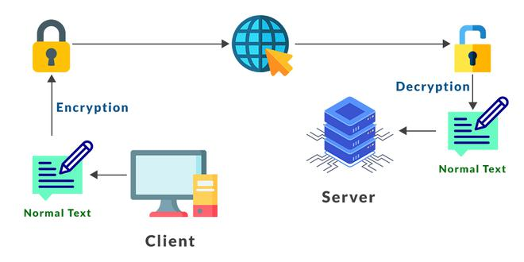
SFTP – ( Secure file transfer protocol):
- A network protocol for accessing, transferring, and managing large amounts of sensitive data.
- Extension is SSH
- Provide a high level of security for sending and receiving files.

Configuration of SFTP for Windows –
- In most Windows OS, SSH is preinstalled, else first install SSH in your system from open source.
- Open the control panel and search for “Window Defaulter firewall”, then click on “Advanced settings”.
- A new popup will open, click on “Inbound rules”.
- Now click on “ New rule” in the right corner.
- At last, select an SFTP client to use. Generally, window SFTP clients use WinSCP, FileZilla, and Cyberduck.

